**ING 4 SI 2016/2017**

**Computer networks exam**

**Entrez les réponses avec une courte explication pour que tout le monde comprenne. Si vous n’êtes pas d’accord avec ce qui a été écrit, ajouter votre commentaire sans effacer le précédent.**

1) d

2) d

3) b

4) c

5) a

6) a (a revoir) ---> peut etre la b <https://www.sanfoundry.com/computer-networks-mcqs-reference-models/> non c’est la a d’après ce site

7) a

8) d

9) a

10) c

11) a

12) b //D

13) b peut etre // A

14) b

False, a hub is a layer 1 device.

15) b

False, a bridge is a layer 2 device

16) a

17) a

18) d

19) c

20) d

21) b

22) c

23) c

24) c

32-22 = 10 bits left for subnet + hosts. 16 hosts + 1 broadcast address + 1 subnet address = 18 hence we need 5 bits for the host part, which leaves us with 5 bits for the subnet part. 2⁵ = 32 different subnets.

25) d

22 bits for the mask ⇒ 10 bits remaining

2^4 = 16 > (13+2) ⇒ 4 bits needed to handle 13 hosts ⇒ 10 - 4= 6 bits remaining for the subnets

2^6 = 64 subnets possible.

26)c

22 bits for the mask ⇒ 10 bits remaining

2^5 = 32 > (26+2) ⇒ 5 bits needed to handle 26 hosts ⇒ 10 - 5= 5 bits remaining for the subnets

2^5=32 different subnets

27)c

/27 subnet mask -> 11111111.11111111.11111111.11100000

Final result -> 223.52.12.00100000 = 223.52.12.32

28)c

/28 subnet mask -> 11111111.11111111.11111111.11110000

Final result -> 223.52.12.00100000 = 223.52.12.32

29) c

30) b

31) a

32) d

33) a

34) a

35) c

36) a

Transport layer protocols are implemented in end systems and not in network routers.

37) a

TCP provides apps a way to deliver (and receive) an ordered and error-checked stream of information packets over the network. The User Datagram Protocol (UDP) is used by apps to deliver a faster stream of information by doing away with error-checking. There for the choice between TCP or UDP is up to its developer, and the choice depends on what an application needs. Most apps need the error-correction and robustness of TCP, but some applications need the speed and reduced overhead of UDP.

38) b

TCP because it needs the the error-correction

39) a

UDP is a connectionless service

40) c

Internet's connection oriented service is TCP

3 Way Handshake(SYN,SYN-ACK,ACK)

41) d

42) b

43) b

BOTH A AND B

“Slow start begins initially with a congestion window size (cwnd) of 1, 2, 4 or 10 MSS.[[7]](https://en.wikipedia.org/wiki/TCP_congestion_control#cite_note-9)[[3]](https://en.wikipedia.org/wiki/TCP_congestion_control#cite_note-RFC_3390-3):1The value for the congestion window size will be increased by one with each [acknowledgement](https://en.wikipedia.org/wiki/Acknowledgement_(data_networks)) (ACK) received, effectively doubling the window size each round-trip time.[[c]](https://en.wikipedia.org/wiki/TCP_congestion_control#cite_note-10) The transmission rate will be increased by the slow-start algorithm until either a loss is detected, or the receiver's advertised window (rwnd) is the limiting factor, or *ssthresh* is reached. If a loss event occurs, TCP assumes that it is due to network congestion and takes steps to reduce the offered load on the network. These measurements depend on the exact TCP congestion avoidance algorithm used.”

https://www.youtube.com/watch?v=ObOVClMZXGM

44) a

// **C**, on the first decrease we can see it is also triggered when 3 duplicate ACK are received

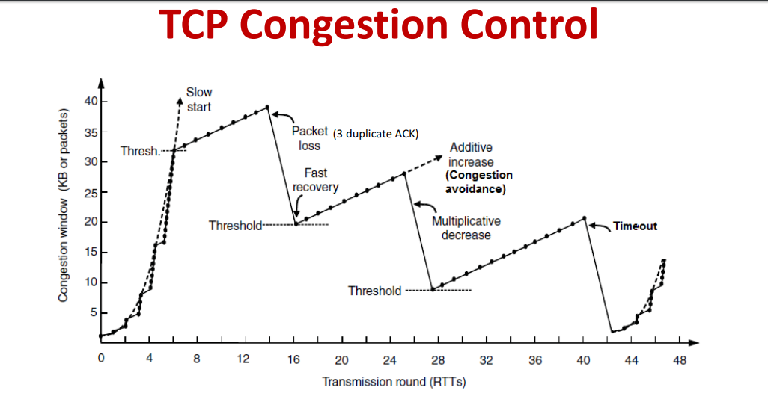

45) d

46) c

47) b

48) b

49) b // D vlan separate the networks, so it is safer, because networks are separated there is less congestion when a broadcast storm happens on one of the vlans ( it constrains the storm on one vlan)

50) a

